**Here is the brief working explanation of my frontend with Screenshots**

* Home pageof my Articles website. Data is loaded properly from backend and displayed on homepage.

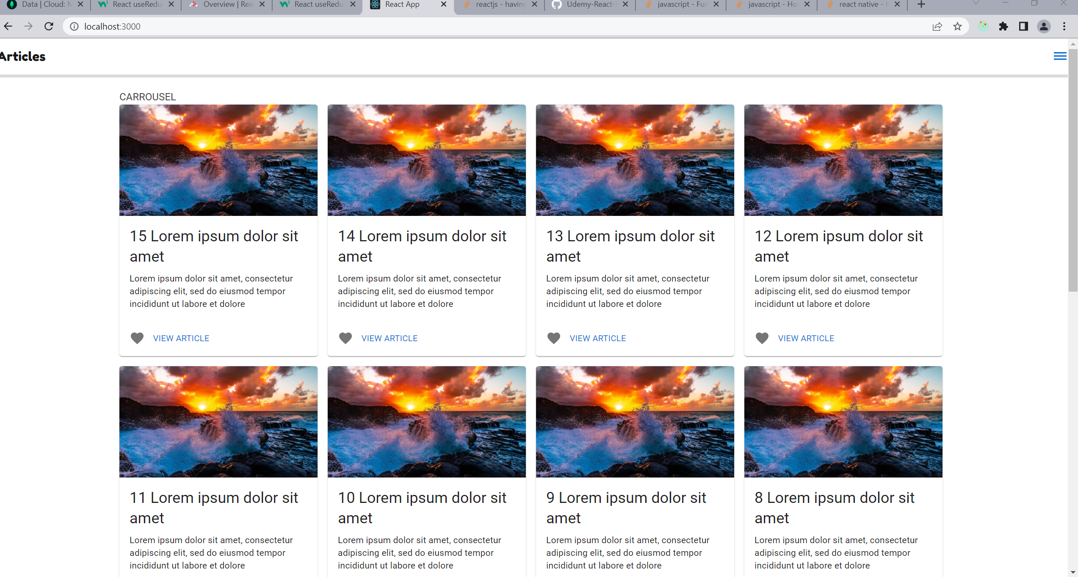

* Side Drawer for the users of my site , to signin/signout and also registration of a new user. Dashboard for admins. All defined routes are in working conditions, I use axios for routing purpose

* Authentication page , for user registration and also for validation when user login my website. A cookie is generate and send to the browser which stores in browser memory

* Dashboard for my registered Users.

* Registered user’s data stored In MongoDB Database.

* Articles related data stored In Database.

* Redux store for state management of articles related data.

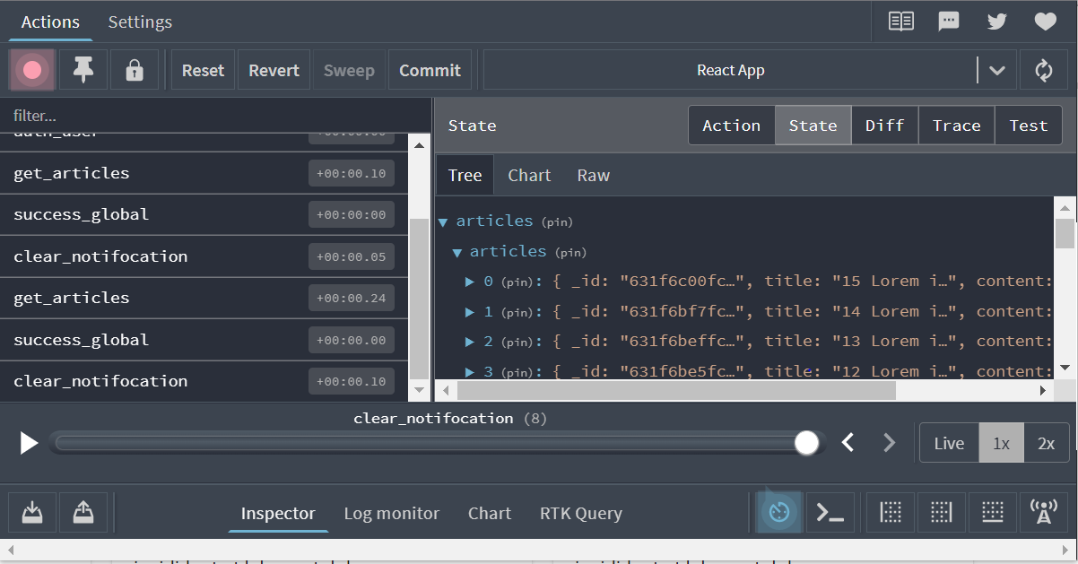

* State management for users , if users are not signin then no authentication is needed and state remains false.

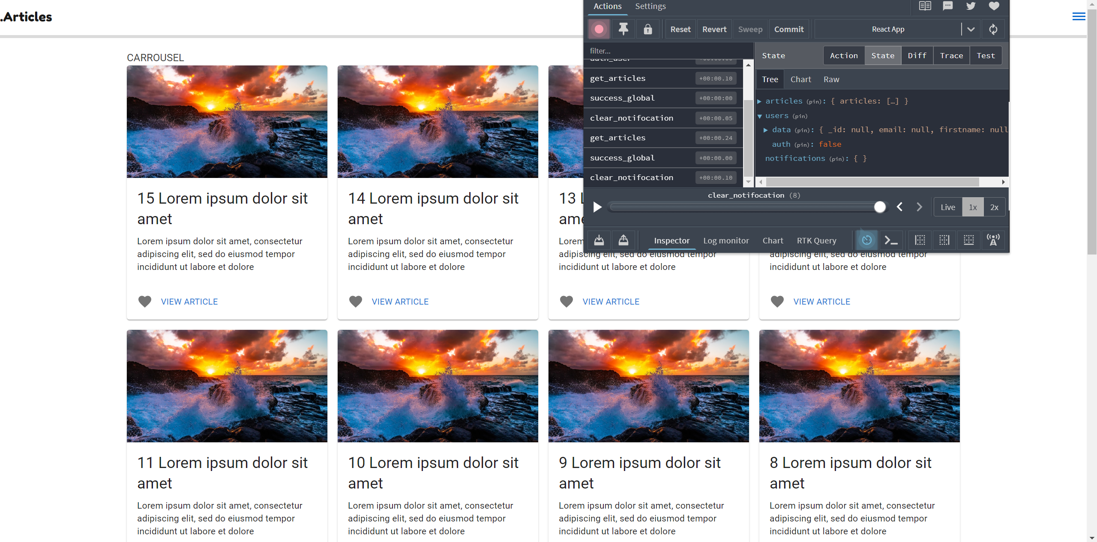

* If user is signin then state for users change into True and the cookie become stored In browser then user redirects to the dashboard page.

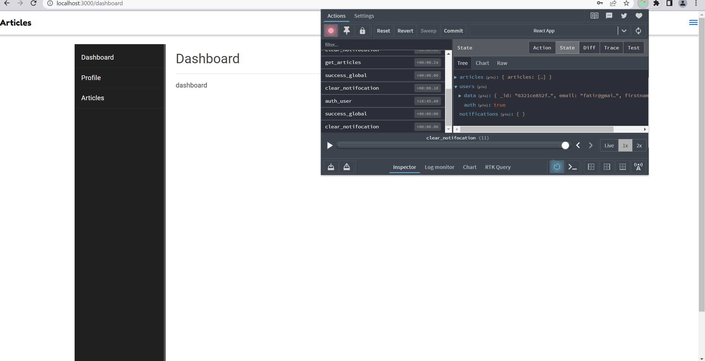

* Here is the cookie information for the user’s authentication.

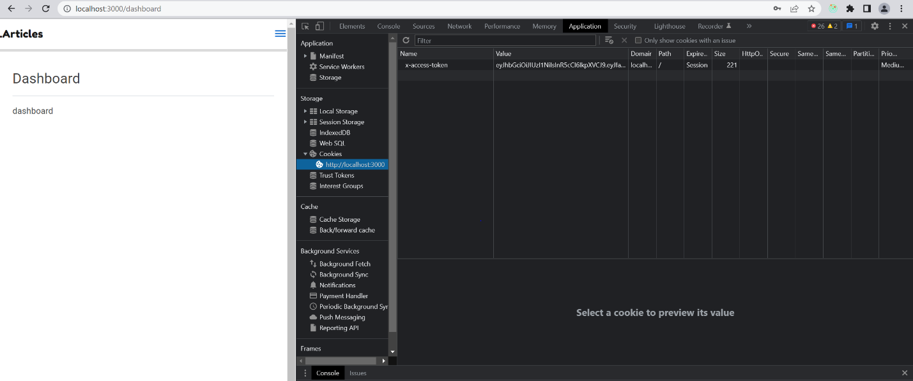

* I followed proper instructions, I used camelCase in programming and proper folders structure to meet the requirements of React.js. Its saved me a lot from unnecessary prop drillings.
* If you want to install the packages related to my frontend end , I put all the relevant packages in the “info.md” file so that you can easily install them and test the frontend.
* I also attach a raw sample data file with the name of “data.json” so that you can upload that data on MongoDB and test my frontend.

That’s All till now , However, I’m still learning and working on my website

Improve the further extension in it (by working on Dashboard and other relevant features related to it).

--------------------------------------- **Thank you** --------------------------------------